# Testing Results

## Test Table

|  |  |  |  |
| --- | --- | --- | --- |
| Server | | | |
| Description | | **Expected Results** | **Actual Results** |
| Start Server | | Server runs | Ref 1 |
| Start button is disabled |
| Receive user credentials for login/switch and check | User credentials are correct | Send result to client | Ref 2 |
| Display username in textbox |
| User credentials are incorrect | Display error message | Ref 3 |
| Receive user credentials to create new user | | Display message user has been created | Ref 4 |

|  |  |  |  |  |
| --- | --- | --- | --- | --- |
| Client | | | | |
| Description | | | **Expected Results** | **Actual Results** |
| Click on connect button | | | Connect to server | Ref 5 |
| Unlock login field |
| Connect button is disabled |
| Click on login button | Complete information | | Send credentials to server | Ref 6 |
| Incomplete information | | Display error message | Ref 7 |
| Receive login result from server | | | Clear login textboxes | Ref 8 |
| Display username |
| Display movies list |
| Unlock all fields |
| Click on switch button | | | Clear all textboxes and lists | Ref 9 |
| Implement login |
| Lock all fields except login |
| Click on create button | If create field is unlock | Complete information | Send credentials to server | Ref 10 |
| Incomplete information | Display error message | Ref 11 |

|  |  |  |  |
| --- | --- | --- | --- |
| Receive create results from server | | Clear textboxes | Ref 12 |
| Click on clear button | | All fields regarding login and create is cleared | Ref 13 |
| Click on search button | Complete information | Search according to type (id, title) chosen | Ref 14 |
| Display result in list |
| Incomplete information | Display error message | Ref 15 |
| Click on add button | Complete information | Add movie to csv file | Ref 16 |
| Clear add text fields |
| Incomplete information | Display error message | Ref 17 |
| Sort according to ID button clicked | | List is sorted according to ID | Ref 18 |
| Sort according to title button clicked | | List is sorted according to title | Ref 19 |
| Click on clear search button | | All fields regarding search is cleared | Ref 20 |
| Click on an item in movies list | | Display the details of the selected movie in details textboxes | Ref 21 |
| Clear selected in search list |

|  |  |  |  |
| --- | --- | --- | --- |
| Click on an item in search list | | Display the details of the selected movie in details textboxes | Ref 22 |
| Clear selected in movies list |
| Click on next button | No movie currently selected / last movie is selected | Display details of the first movie | Ref 23 |
| Other movie selected | Display details of the next movie in the list | Ref 24 |
| Click on previous button | No movie currently selected / first movie is selected | Display details of the last movie | Ref 25 |
| Other movie selected | Display details of the previous movie in the list | Ref 26 |
| Click on reset button | | Clear details field | Ref 27 |
| Clear selected index in movies list and search list |

Ref 1

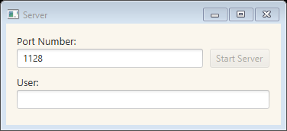

Ref 2

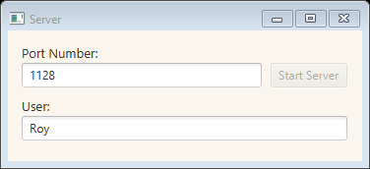 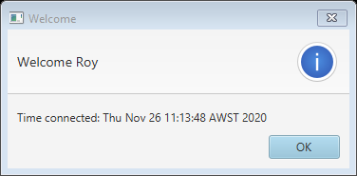

Ref 3

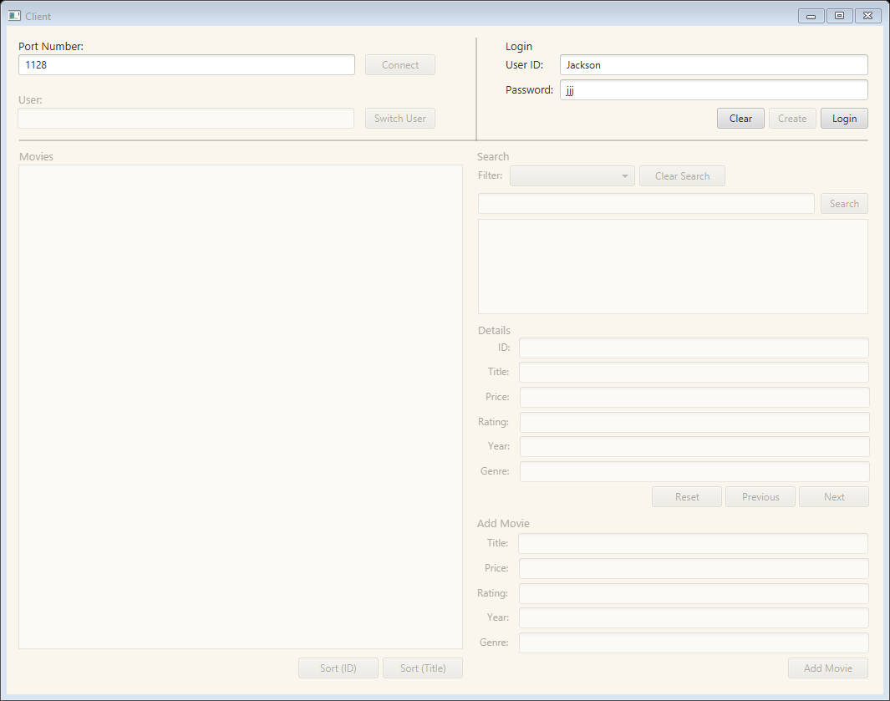 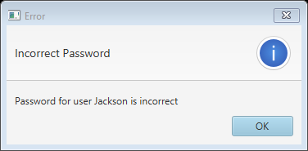

Ref 4

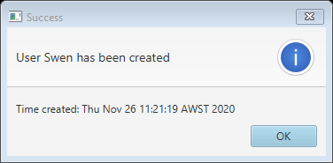

Ref 5

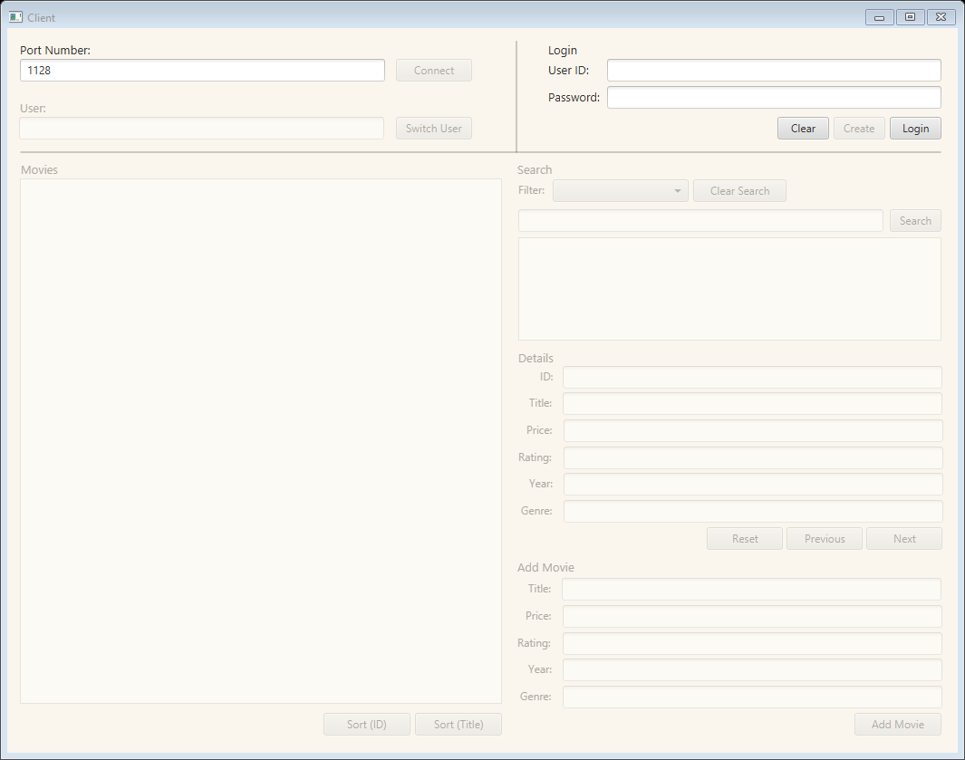

Ref 6

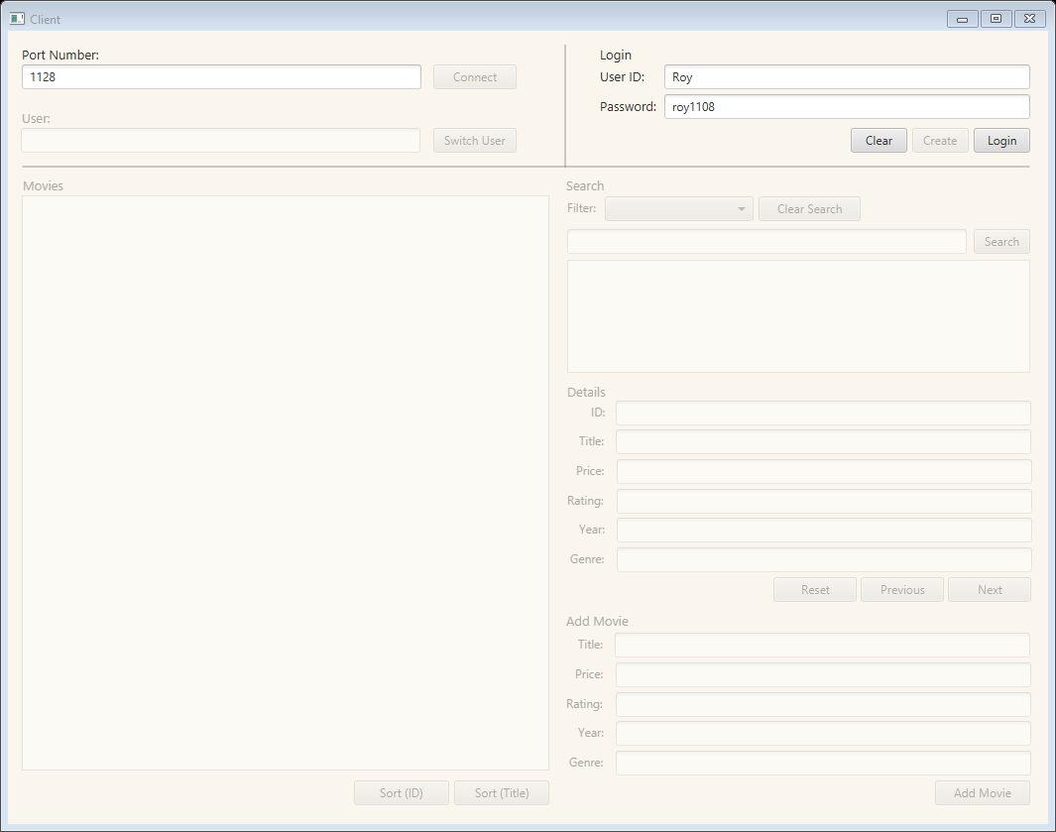

Ref 7

 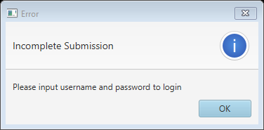

Ref 8

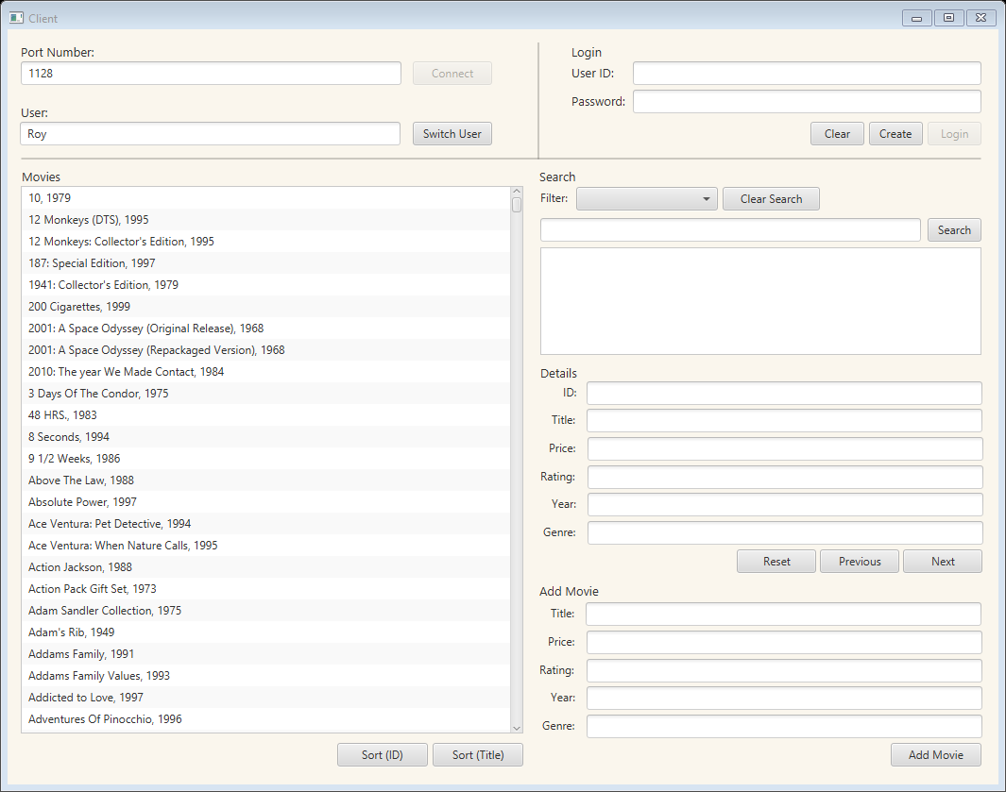

Ref 9



Ref 10

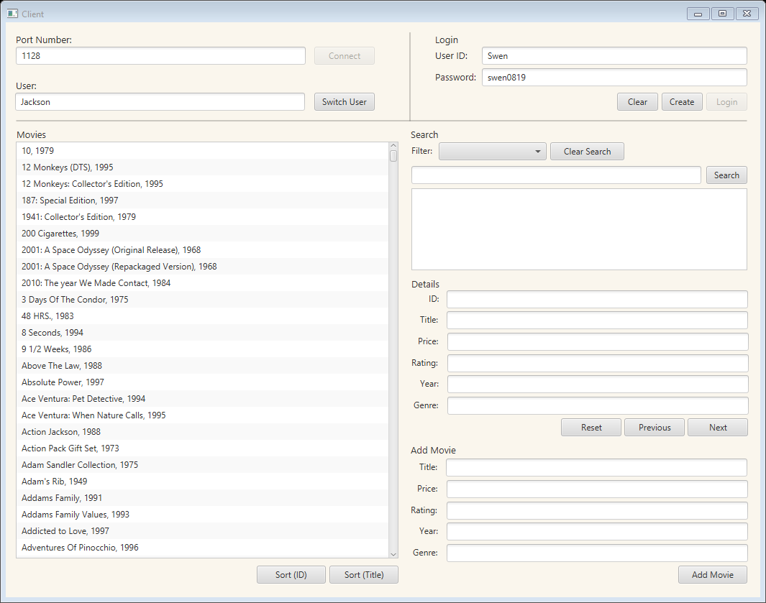

Ref 11

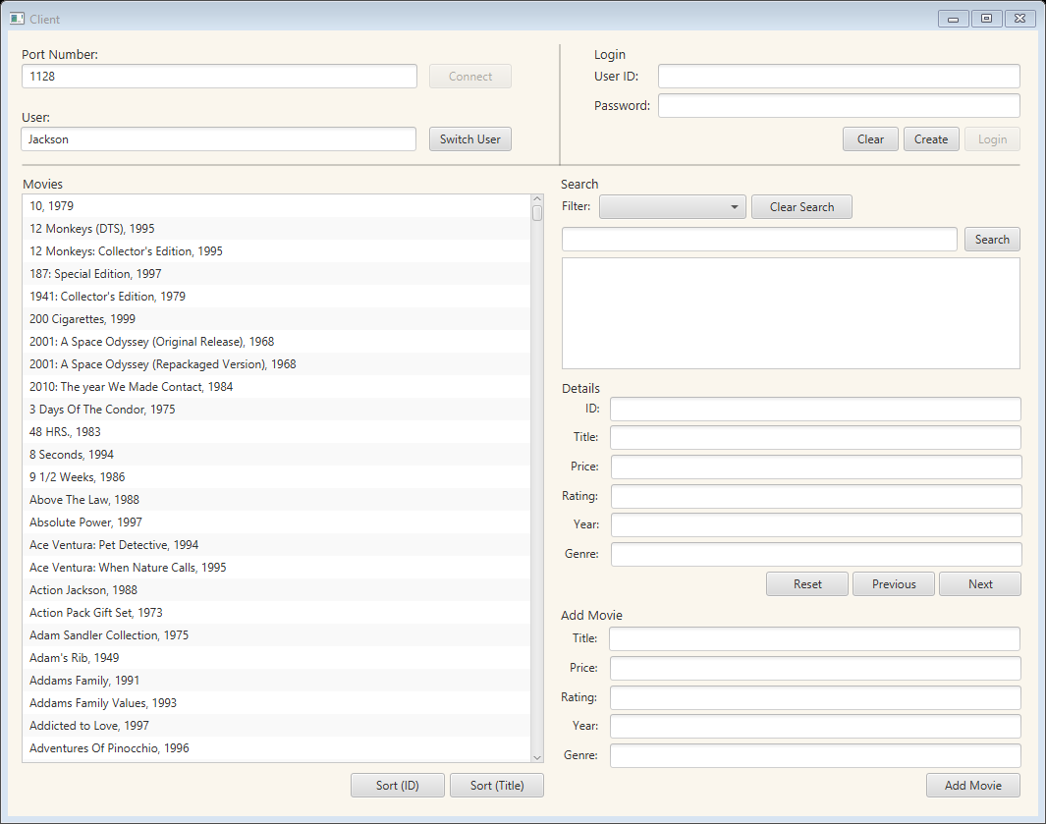 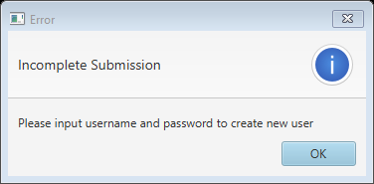

Ref 12



Ref 13

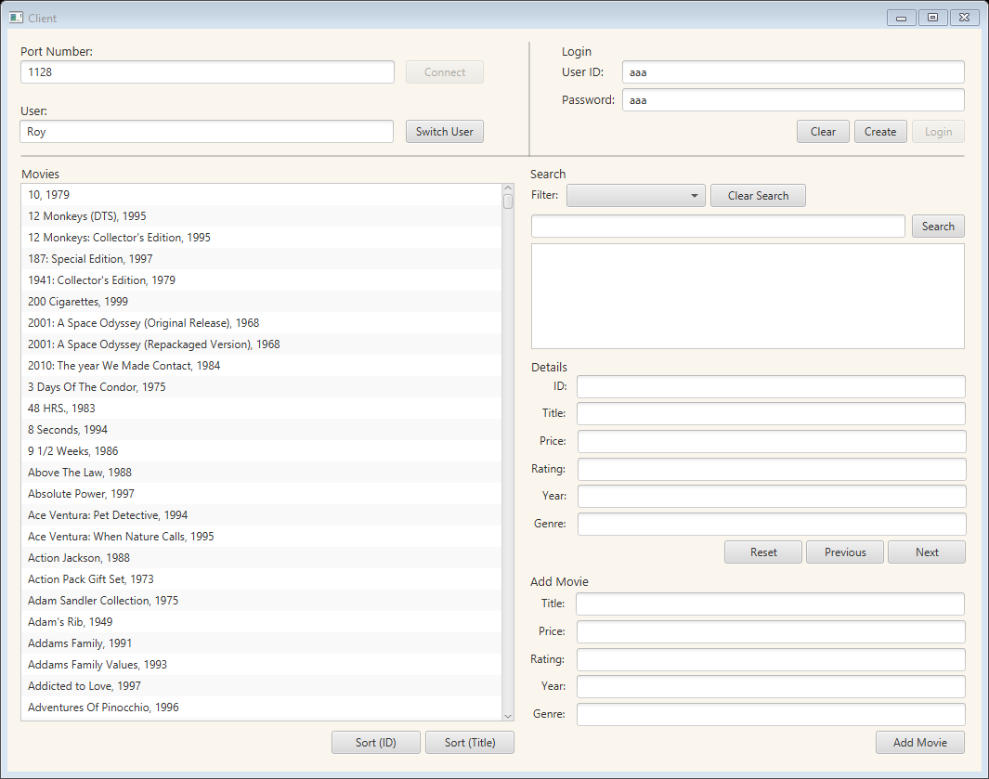.

Ref 14

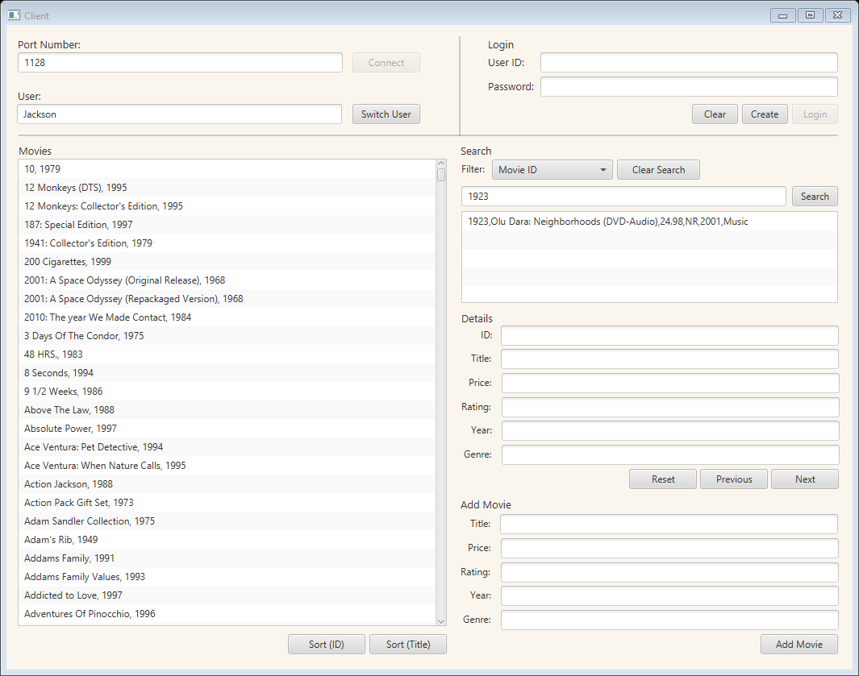

Ref 15

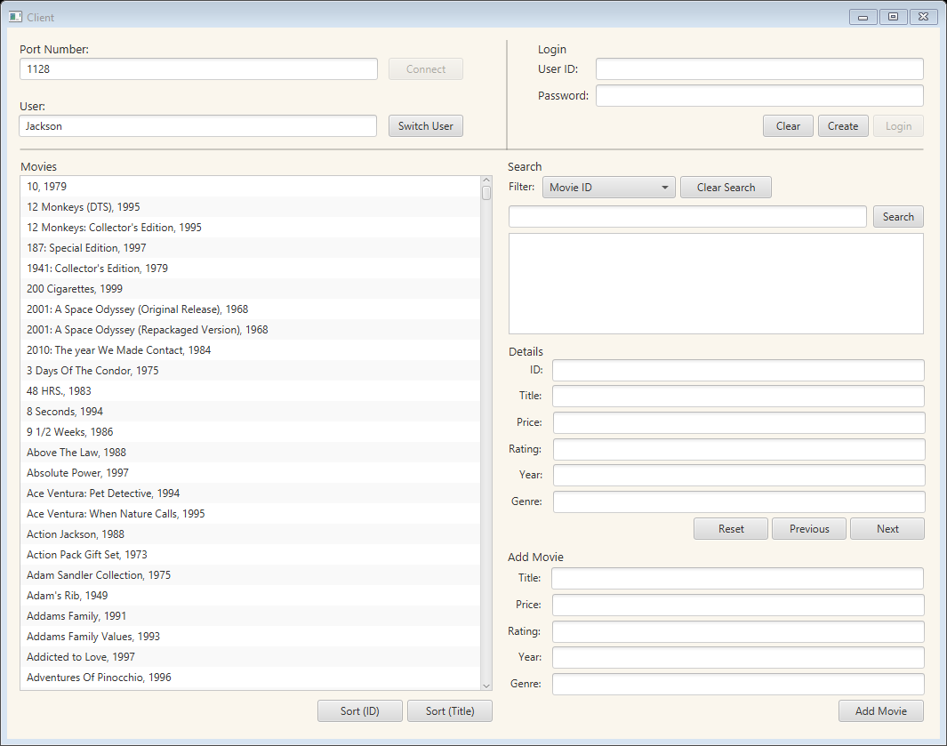 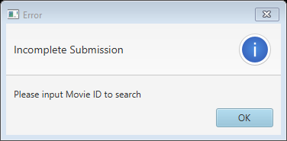

Ref 16

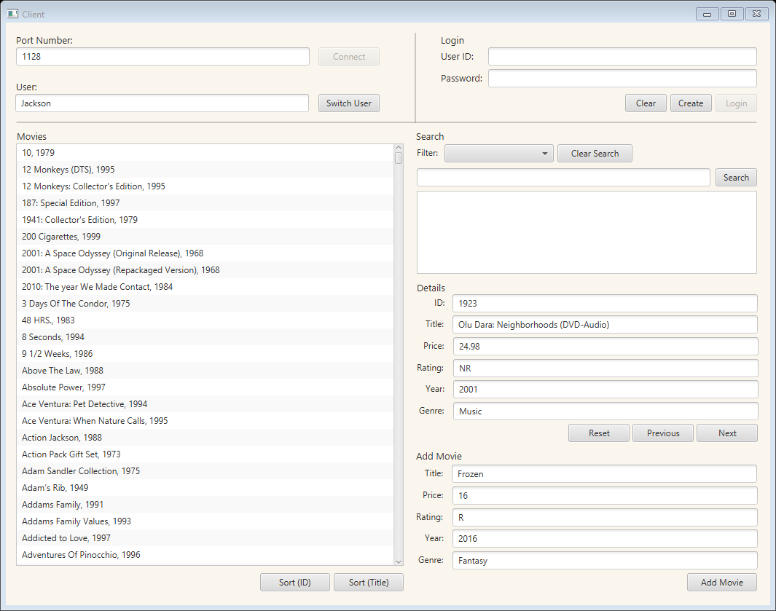

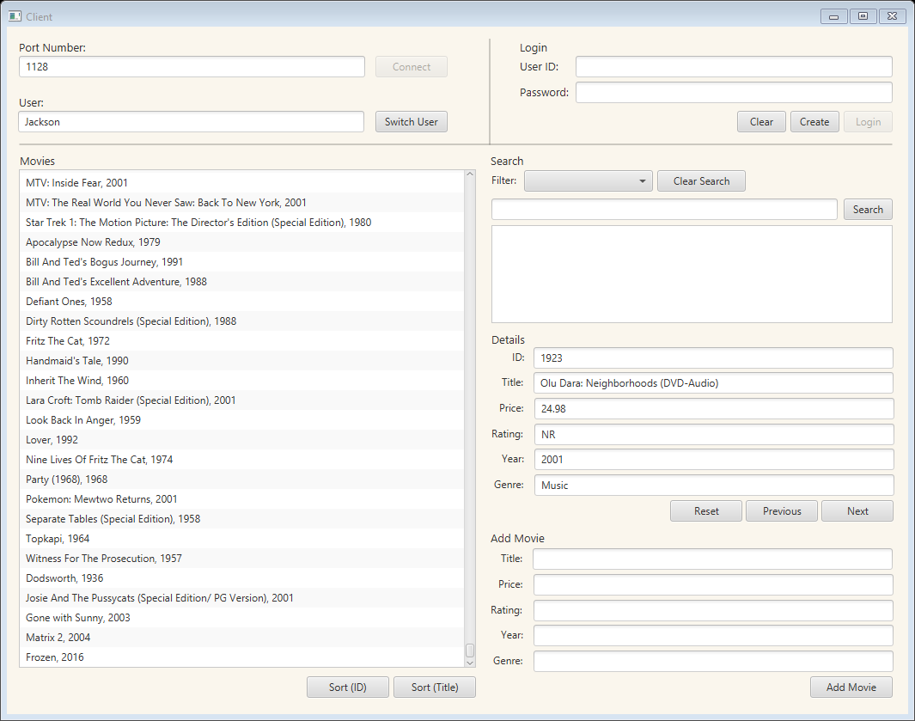

Ref 17

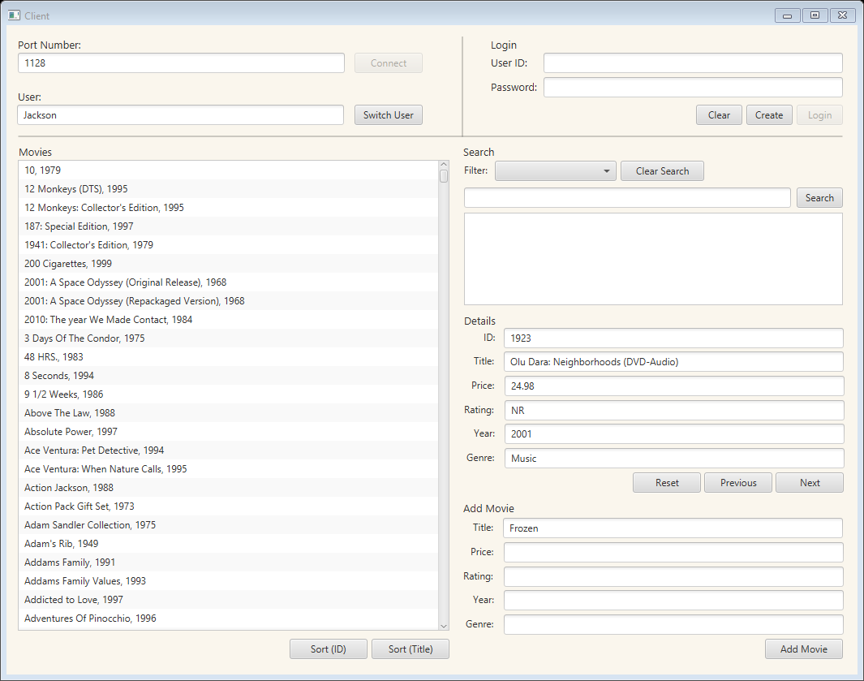 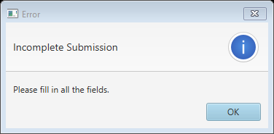

Ref 18



Ref 19

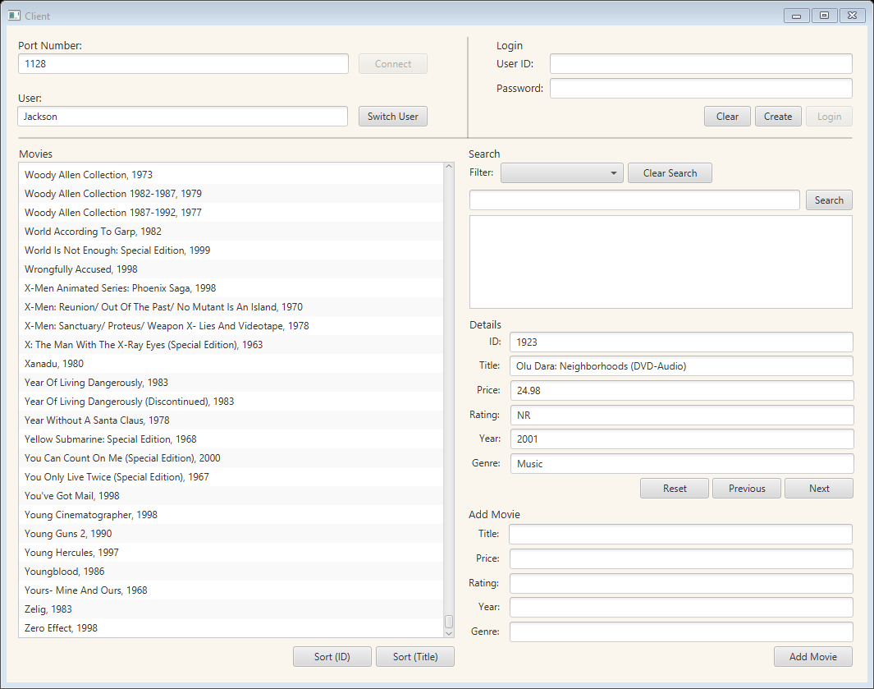

Ref 20

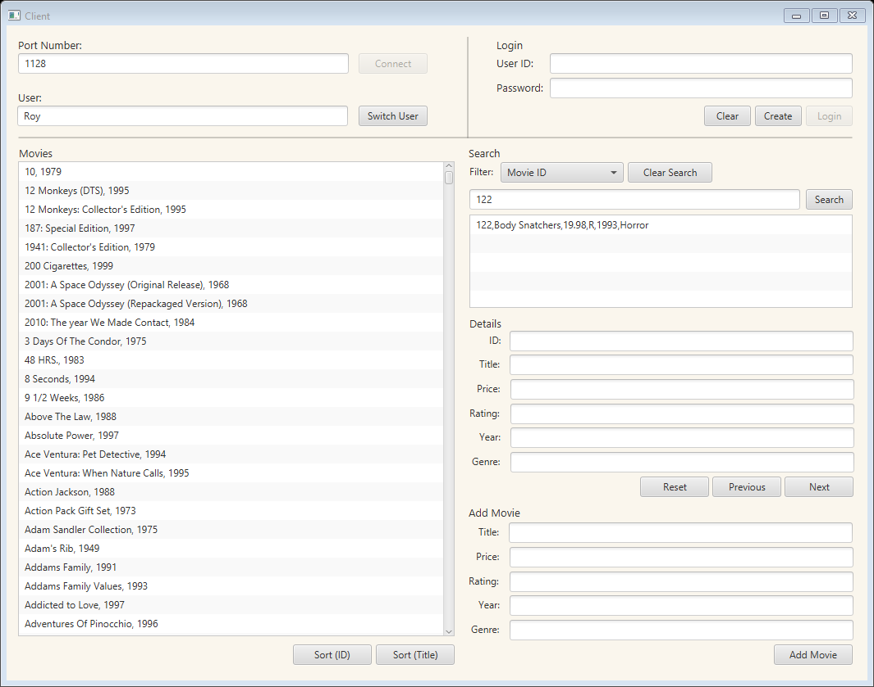 

Ref 21

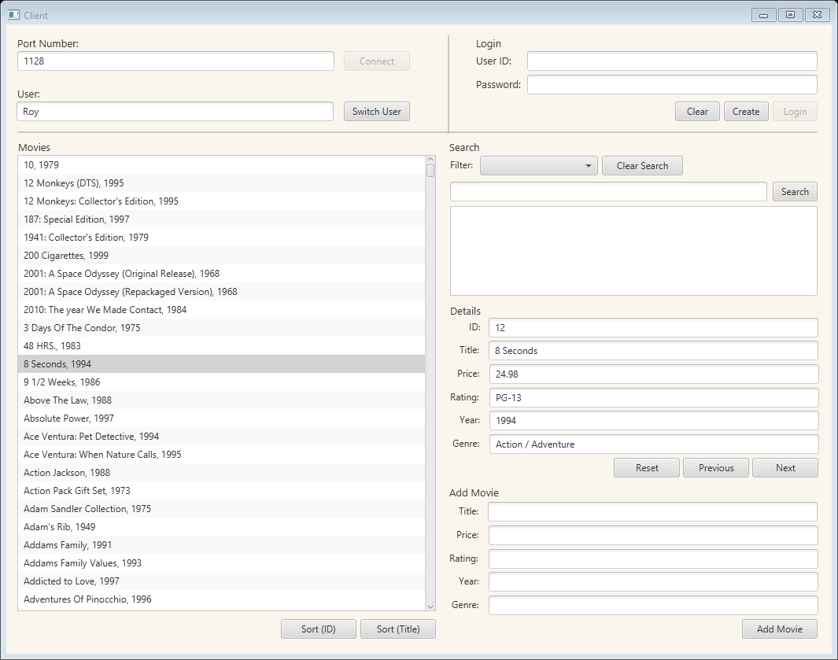

Ref 22

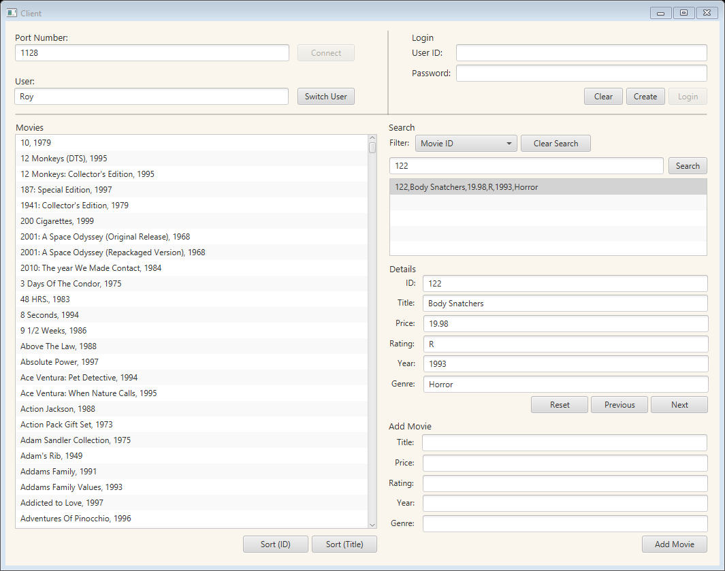

Ref 23

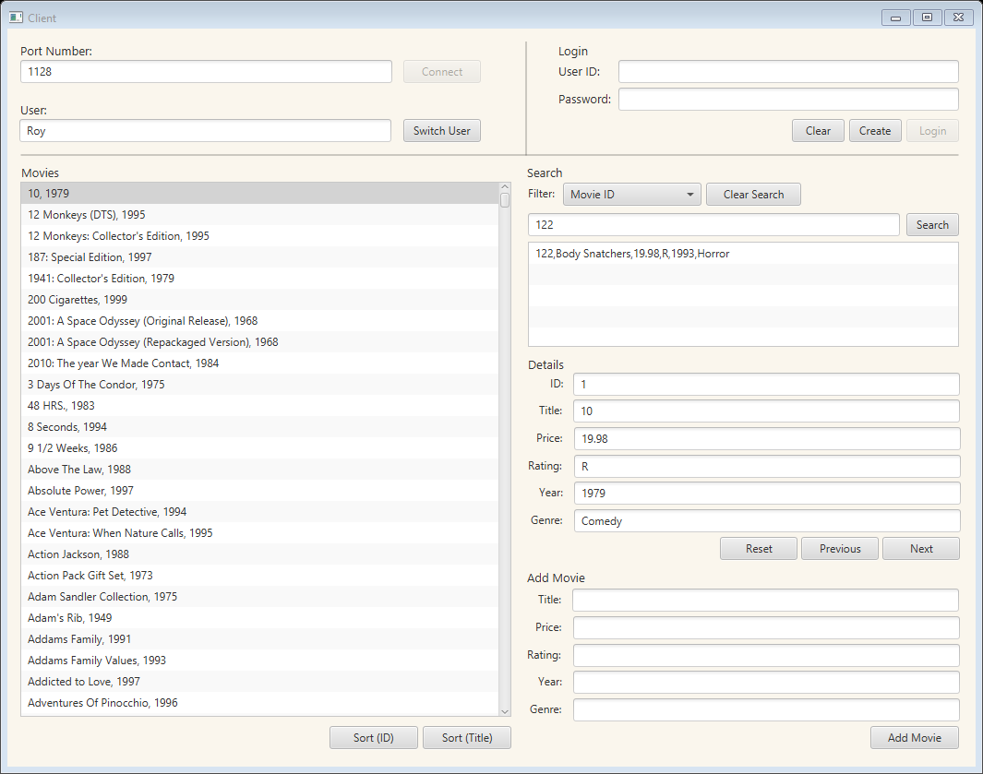

Ref 24

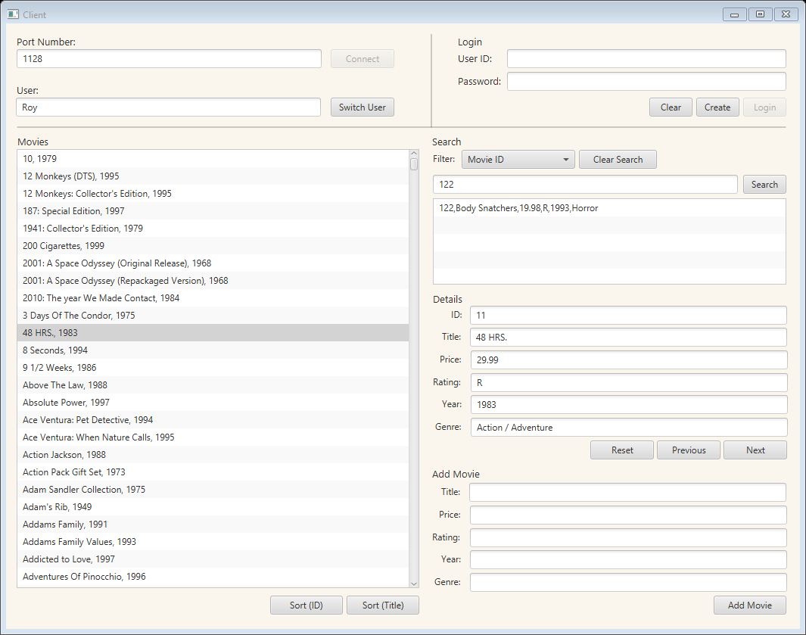

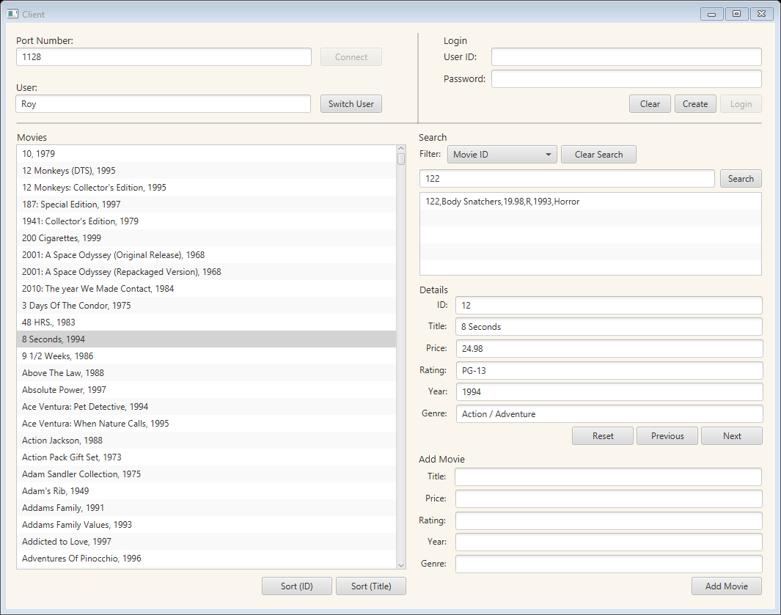

Ref 25

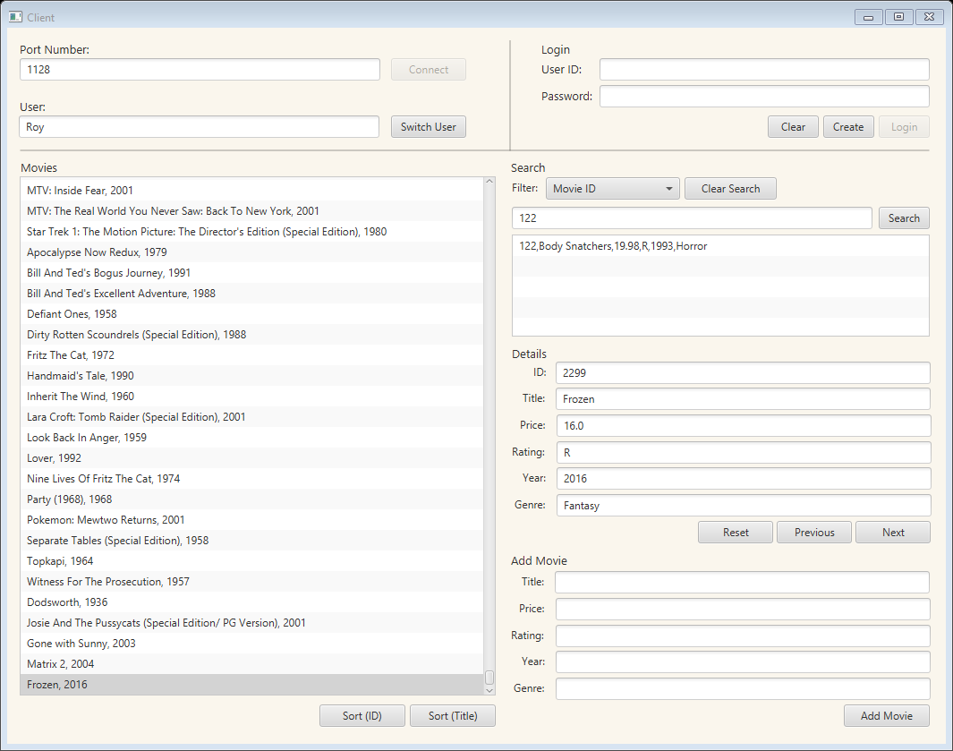

Ref 26



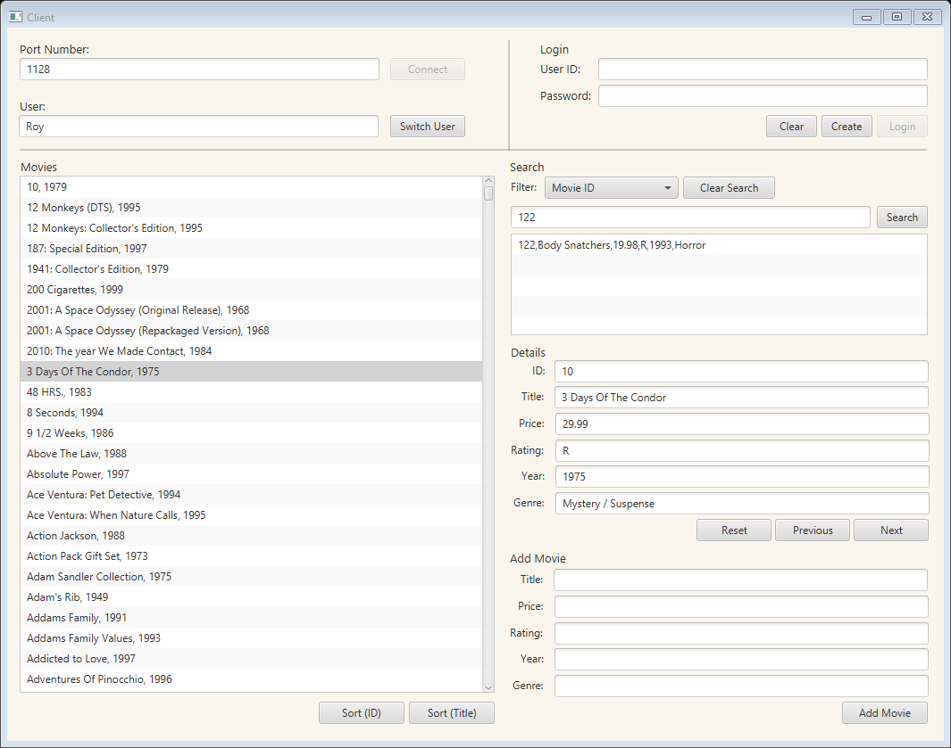

Ref 27



